✅ What is an Exception?
An Exception is an unwanted event that occurs during runtime and disrupts the normal flow of the program.
If not handled, it leads to abnormal (abrupt) termination of the program.
👉 Handling an exception means:
The program should not terminate abruptly.
Instead, it should handle the problem and continue execution normally.

✅ Compile-Time Error vs Runtime Error
🔹 Compile-Time Error
- Occurs during compilation.
- Caused by syntax mistakes.
- Example:
  - Missing ;
  - Missing { }
  - Wrong method declaration
The program will not compile.

🔹 Runtime Error
- Occurs during execution.
- Happens after successful compilation.
- Example:
  - Divide by zero → ArithmeticException
  - Null reference → NullPointerException
  - Array index out of range → ArrayIndexOutOfBoundsException
The program compiles successfully but crashes while running.

✅ Error vs Exception (Very Important Concept)
In Java, both are subclasses of Throwable.
🔹 Errors
- Serious problems.
- Not usually handled by programmers.
- Caused by JVM or system issues.
- Example:
  - OutOfMemoryError
  - StackOverflowError
These are generally not recoverable.

🔹 Exceptions
- Problems that can be handled.
- Caused by program logic or external conditions.
- Can be recovered using try-catch.

✅ Types of Exceptions
1️⃣ Checked Exceptions
- Checked at compile time.
- Must be handled using try-catch or throws.
- Example:
  - IOException
  - SQLException
If not handled → compiler error.

2️⃣ Unchecked Exceptions (Runtime Exceptions)
- Not checked at compile time.
- Occur at runtime.
- Example:
  - ArithmeticException
  - NullPointerException
  - IllegalArgumentException
  - ArrayIndexOutOfBoundsException
Handling is optional, but recommended.

✅ How Exception Occurs (Step-by-Step Flow)

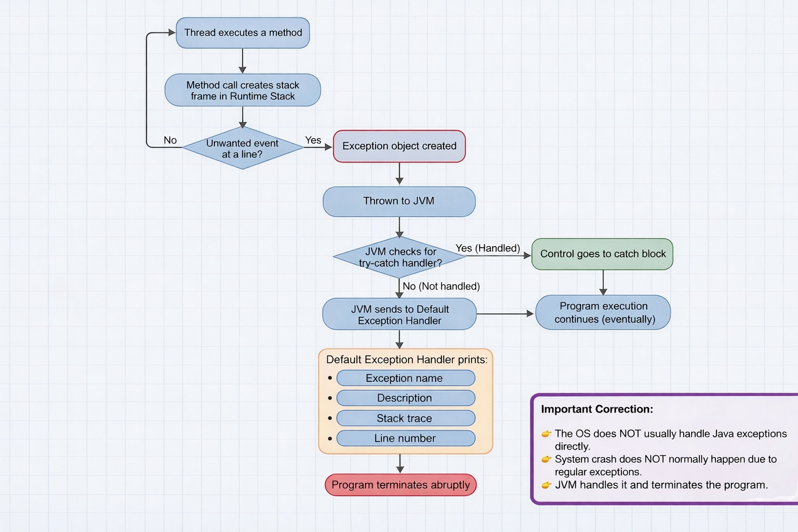
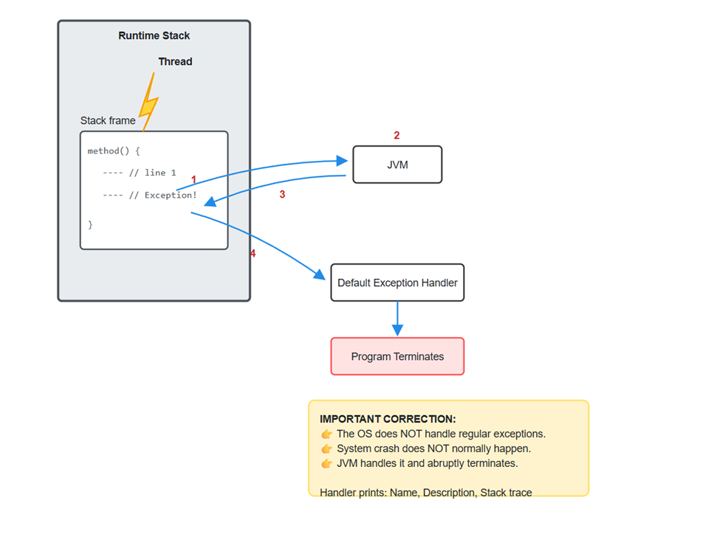

When a thread executes a method:
- Each method call creates a stack frame inside the runtime stack.
If an unwanted event happens at a line, an Exception object is created.
- That object is thrown to the JVM.
- JVM checks whether the exception is handled using try-catch.
If handled → control goes to catch block.
- If not handled → JVM sends it to Default Exception Handler.
Default Exception Handler prints:
  - Exception name
  - Description
  - Stack trace
  - Line number
Program terminates abruptly.

✅ Example
Exception in thread "main" java.lang.ArithmeticException: / by zero
at Exception_Eg1.main(Exception_Eg1.java:10)
Meaning:
- Exception type: ArithmeticException
- Reason: divide by zero
- Occurred in main method
- Line number: 10
- Not handled → default exception handler terminated program.

Eg: Exception_Eg1

✅ Handling the Exception (try-catch)
Purpose:
Prevent abrupt termination.
Basic Syntax:
try {
// risky code
}
catch (ExceptionType e) {
// handling code
}

✅ Important Rules of try-catch
- Risky code must be inside try.
- After try, at least one catch or finally must be present.
- If exception occurs:
  - Remaining code inside try is skipped.
  - Control directly goes to matching catch block.
- Catch block executes only if exception occurs.
- After catch block, program continues normally.
- If exception does NOT occur:
  - Catch block will not execute.
  - Program runs normally.

✅ What to Write in Catch Block?
Inside catch block:
- Show user-friendly message.
- Log error.
- Take corrective action.
- Provide alternate logic.
Example:
catch (ArithmeticException e) {
System.out.println("Cannot divide by zero.");
}

Eg: Exceptional_Handling_Try_Catch

✅ Using Parent Class "Exception"
catch (Exception e)
- Exception is parent of most exception classes.
- It can catch almost all exceptions.
- But it is NOT recommended to use only generic catch.
Why?
Because:
- User will not know exact problem.
- Debugging becomes difficult.
- Not industry best practice.

✅ Multiple Catch Blocks
One try block can have multiple catch blocks.
Example:
try {
// risky code
}
catch (ArithmeticException e) {
System.out.println("Divide by zero error.");
}
catch (NegativeArraySizeException e) {
System.out.println("Array size cannot be negative.");
}
catch (ArrayIndexOutOfBoundsException e) {
System.out.println("Index out of range.");
}
Rules:
- Only one catch block executes.
- Matching catch block executes.
- Remaining catch blocks are skipped.

Eg: Multi_Catch_Demo

✅ Generic Catch Block (Best Practice)
Sometimes unexpected exception may occur.
So we add:
catch (Exception e) {
System.out.println("Unexpected error occurred.");
}
Important Rule:
👉 Generic catch block must be last.
If placed before specific catch blocks → compiler error.
Because parent cannot come before child.

Eg: MultiCatchWithGeneric

✅ If Programmer Handles Exception, Will Default Handler Run?
No.
If exception is properly handled,
Default exception handler will NOT execute.

✅ What Happens If Exception Is Not Handled?
- JVM default exception handler prints stack trace.
- Program terminates.
- Remaining code will not execute.

✅ Finally Block
finally block executes whether exception occurs or not.
Used for:
- Closing resources
- Releasing connections
- Cleaning memory
Example:
try {
// risky code
}
catch (Exception e) {
System.out.println("Handled.");
}
finally {
System.out.println("Cleanup code.");
}
Finally always runs (except JVM crash or System.exit()).

Eg: FinallyDemo

✅ Industry Recommended Structure
- Identify risky code.
- Keep only risky statements inside try.
- Use specific catch blocks.
- Add generic catch at last.
- Use meaningful messages.
- Log exceptions in real projects.
- Do not leave empty catch blocks.
Example:
try {
int result = a / b;
}
catch (ArithmeticException e) {
System.out.println("Invalid division operation.");
}
catch (Exception e) {
System.out.println("Unexpected error occurred.");
}
System.out.println("Program continues...");

Eg: IndustryExceptionDemo

✅ Very Important Concept – Exception Propagation
If a method does not handle exception,
It is propagated to the calling method.
If main method also does not handle,
Then default exception handler executes.

